A Beautiful Memorable Journey In Lyon France and Europe
Beautiful, authentic town that is how I will describe Lyon, France. It was a big opportunity for me to step into this town for the ESVS.
I registered myself on 20th September 2017. Every single station in ESVS were attended by friendly organizer. I put up my poster at the booth and help by the organizer. I manage to speak to few delegates from China, Spain and Ireland. I am proud to tell them I am a Malaysians and promoting the coming event ASVS ( Asian Surgical Vascular Society) in October 2017.
Lectures started on the next day. The topics discussed were informative, simplified and up to date. Every single lecture were well organized and supported with evidence. The most favourite lectures were the Carotid artery disease and mesenteric ischaemia. The lecture was compartmentalized and every subtopic was well delivered by the experts. The lectures will definitely help me in managing my patients.
I was really impressed with the way the ESVS was conducted. It was well organized and punctual. It was supported by the high technology system. The organizer was friendly and helpful. I feel like at my own home.
During the last day I was in Lyon, I manage to have a walk in the town. There were a lot of old building and church to visit. Lyon is a UNESCO World Heritage Site.The city is known for its cuisine and gastronomy and historical and architectural landmarks. We took photograph at the Lyon Area. There were a lot of shops those selling good leather goods with a very reasonable price. I got myself a bag and a pair of shoe. The climate was quite good. We went to visit few building such as The church of Saint Francis of Sales, The Opera Nouvel and the African Museum. We return back to Malaysia with mixed feelings.
I do really hope that I will be able to join the event again next year.

Lenny Suryani Safri
Malaysia

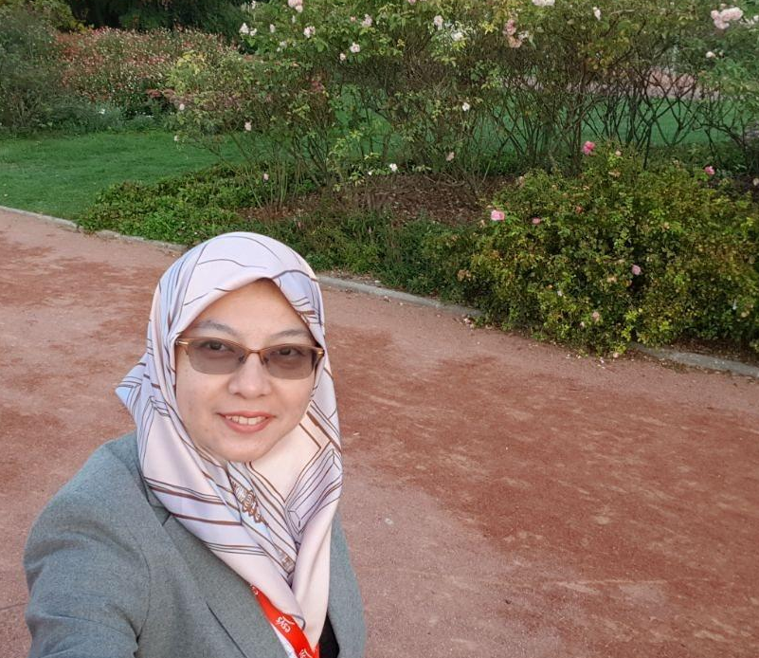

I was at the park opposite the Conference hall

