Attending the 2017 ESVS Annual Meeting in Lyon – Perspective of an American Vascular Surgeon
Windsor Ting MD, Mount Sinai Medical Center, NY.
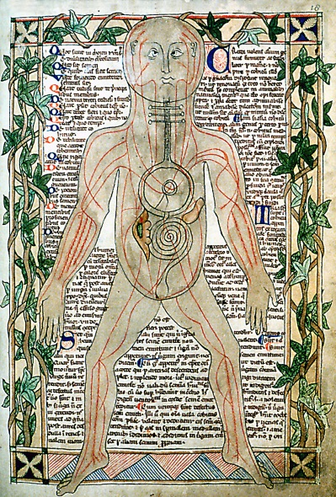 A 13th century drawing showing veins in the human body (photograph at the Bodleian Library of a public domain art)

The ESVS annual meeting in Lyon was education at its best.
The meeting provided me with an extraordinary overview of vascular surgery in Europe. Interestingly, it also gave me a fresh perspective of vascular surgery back home in the U.S. I saw advances in vascular surgery at the meeting that will continue the rich history of medicine in Europe.
The journey to Lyon began in a jumbo double-decker Airbus jet. The flight across the Atlantic Ocean took seven hours. On arrival in Lyon and over four days, I saw in the Lyon the blending of a modern French city with 2,000 years of antiquity. The amphitheater of Fourviere has its origin in 15 BC. The Lyon Congress Center is a much more recent architecture.
On the first day of the conference, over a hundred fast track presentations provided a quick view of clinical studies and some basic science research ranging from complex aortic aneurysms to acute limb ischemia to venous thrombosis and many other subject matters. These studies, conducted in small local hospitals to major medical centers across Europe and outside of Europe, are reflective of a dynamic and growing vascular specialty in Europe. It is astonishing to me that Hippocrates, around 300 BC, might have started this adventure in western medicine just 2,000 km away in Ancient Greece.
Over the next two days, I attended delightful lectures and enthusiastic discussions on subjects familiar to me: management of carotid stenosis with surgery versus endovascular approaches, the introduction of vascular surgery to young medical students, guidelines on treatment of chronic peripheral artery disease, and the history of vascular surgery in France. I heard many familiar themes in diagnosis and treatment related to vascular surgery. I have listened to many similar debates in North America. What was incredibly unique to me was that these presentations were from many different countries with different health systems, cultures, and languages. On the same podium sat vascular surgeons form France, Germany, Belgium and England. It was interesting to observe that complex endovascular procedures are centralized in Europe to a far greater degree than in North America. I was able to tell there are endovascular surgeons in Europe who are incredibly skilled and experienced in special vascular conditions. Like Louis Pasteur of the 1800’s, perhaps they too will pave new roads in vascular surgery for the world.
For this vascular surgeon from North America, attending this vascular meeting in Europe was a first but likely the first of many to come. I left the meeting inspired.

